Julianne Lo

UNC Data Analytics Boot Camp

Module 4 Challenge - Python

13July2023

Student Math and Reading Scores in Schools

Figure 1 provides overall summary of 15 schools; it shows average reading score of 81.88, higher than average math score of 78.99. It translates into more students passing reading: 85.81% of students passing reading compared to 74.98% student passing math. Within this school district region, there are 8 schools belong to charter school type and 7 belong to district school type (Figure 2).

By looking at the scores by school type, charter schools showcase better student performance in math and reading. Students from charter schools score between 83 and 84 in math and reading, while students from district schools score between 77 and 81. About 90% of the students from charter schools pass both reading and math, while only about 54% of the students from district schools pass both subjects (Figure 3). The top five performing schools are charter schools while the bottom five are district schools (Figure 4 and 5).

So, does that mean charter schools require more budget to keep their students’ performance? The answer is no. According to the analysis in Figure 6, the top five schools in budget spending per capita are district schools. According to Figure 7, schools spending is not positively correlated to students’ academic performance. In this analysis, schools spending < $585 per capita show better academic performance with about 90% overall passing rate. Based on Figure 6 and 7, it is concluded that spending does not correlate to good academic performance of students.

Further analysis indicates that spending is related to the school size. According to Figure 6, the top five spending schools are also large schools having 2,000-5,000 students. Therefore, poor academic performance could be attributed to low student- to- teacher ratio because there aren’t enough teaching staff supporting large number of students. This assumption is supported by Figure 8, which shows schools with 2,000-,5000 students have poor student performance: < 60% of students passing both math and reading.

In conclusion, charter schools demonstrate economical budget spending per capita because the class sizes are relatively small compared to district schools; this type of school setting provides better learning environments for students because more students get support from teaching staffs compared to students in large district schools. As a result, it promotes better academic performance.

Figure 1 District Regional Summary



Figure 2 School Summary

Figure 3 Scores by School Type

Figure 4 Top Five Highest Performing School by Percent Overall Passing

Figure 5 Bottom Five Performing School by Percent Overall Passing

Figure 6 Top Five School Spending per Student Budget

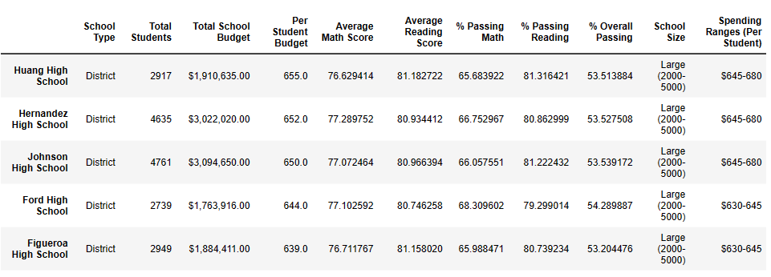

Figure 7 Math & Reading Scores by School Spending

Figure 8 Math & Reading Scores by School Size

